Name: Fall Semester Final Exam Review
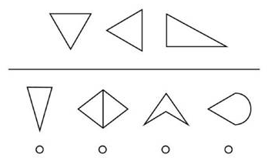
- The shapes on the top are alike in some way so they belong together. Choose one shape from the bottom row that belongs with the figures on top.

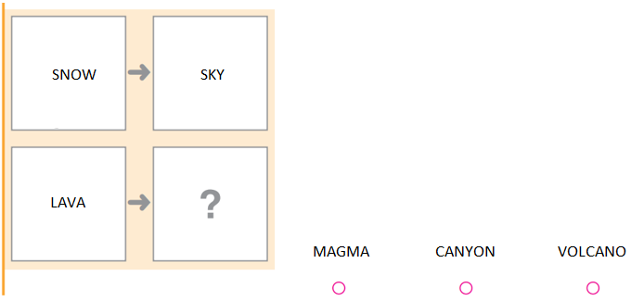
- Fill in the blank for each analogy:
In a complete sentence, explain why you chose that word:

In a complete sentence, explain why you chose that word:

SMILE

________

REPAIR

BREAK
SHORT
TALL

DIFFICULT

________
CAR

WHEEL

BOTTLE
CAP

FINGER

- A group of students were surveyed on their favorite color:

Red | 6
Green | 2
Pink | 6
Blue | 9
Purple | 1

With this data, what is the…
Mode: Median: Range:
Make a bar graph of the data above. Be sure to include a title and number labels.
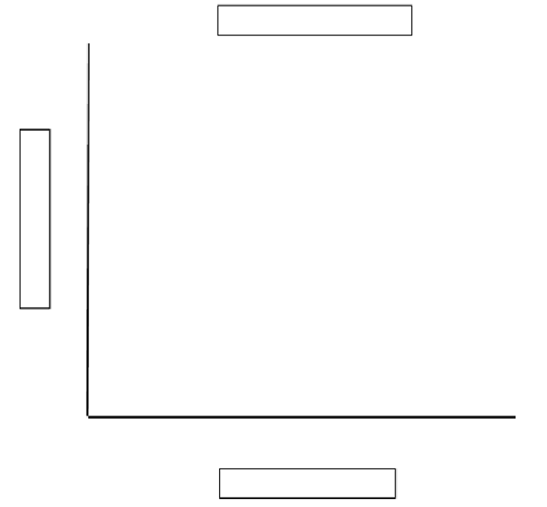
- In the following sentences, UNDERLINE the nouns, BOX the adjectives, STAR the adverbs, and CIRCLE the verbs.
Yesterday I played video games too excitedly and feel very tired now.
The fur on the fluffy dog is so fun to play with and pet quickly.
My friend has not seen her homework since last night when she lost it.
- Fill out the chart with your knowledge of prefixes and suffixes. The first row is done for you as an example.
Word | What prefix or suffix is used in this word? | What is the meaning of this prefix or suffix?
prepare | pre- | before
writer
subway
unclear
prettiest

- Fill in the blanks below:

List the three states of matter:
_____________ _____________ _____________

Does the state of matter have a specific shape?
_____________ _____________ _____________

Rank the temperatures of water, ice, and water vapor from lowest to highest:

_____________ ______________ _____________

- Identify whether each is a solid, liquid, or gas.

  - water vapor _____________
  - clock ______________
  - soda ______________
  - oxygen ___________
  - ice _____________
  - fresh paint _____________

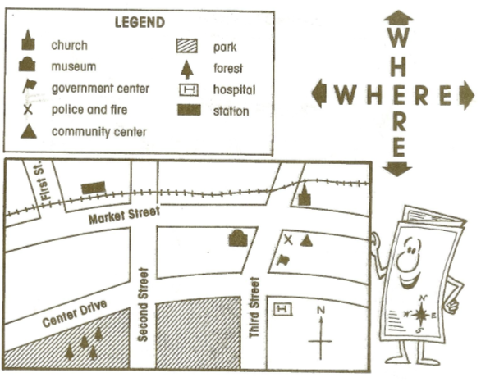
SCALE = 20 feet
- Label N, S, E, and W on the compass rose.
Write North, South, East, or West to complete each of the following sentences.
- The church is to the _________ of the police and fire department.

- The station is to the _________ of the church.

- The forest is to the ________ of the station.

- The community center is to the ________ of the police and fire department.
Look at the map and scale to answer these questions.
- About how far apart are the museum and police and fire department?

- About how wide is the road in terms of feet?

